Use-Case Realization Report
Login

Issue <1.0>
Revision History
Date | Issue | Description | Author
<02/08/09> | <1.0> | <Login> | <Karen Gao>

Table of Contents
1. Brief Description 4
2. Flow of Events 4
2.1 Standard Flow 4
2.2 Exceptions 4
3. Interaction Diagrams 4
3.1 Collaboration Diagram for Login 4
4. Participating Objects 5
5. Class Diagrams 5
5.1 Class Diagram for Login 5
6. Derived Requirements 5

Use-Case Realization Report
Login

Brief Description
This is the login process by the User, Portal Administrator or the User Administrator. Each shall be given a specific password prior to the application and only successful login will have access to different MenuPage respectively according to their rights assigned to.

Flow of Events

Standard Flow

This use case covers the events of Login to the MenuPage, the standard flow of events is described as below:
- The Portal Administrator, User Administrator or the User shall be prompt with the password upon entering the PortalMainPage.
- The password shall be send to the AccessController to processPassword.
- The AccessController shall validate the password through the operation ValidatePassword.
- Then the operation login will inform the MenuController get the respective role from Role object for the one logged in the system.
- The operation displayMenuPage of MenuController will display different MenuPage respectively according the role identified.

Exceptions
If the password is invalid the check by the operation ValidatePassword, a pop up message will be sent to the PortalMainPage.

Interaction Diagrams

Collaboration Diagram for Login
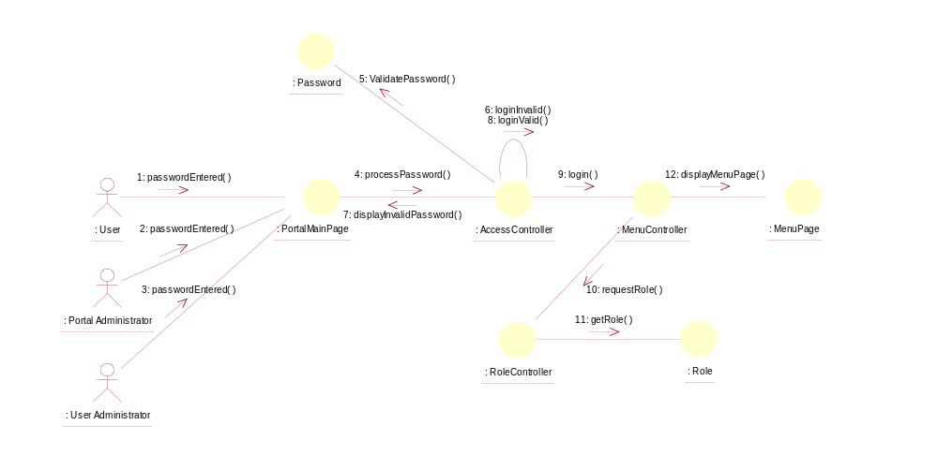

Participating Objects
: Portal Main Page
This is the boundary of PortalMainPage for actors (User, Portal Administrator, User Administrator) to enter the password before access to the next boundary of MenuPage.

: MenuPage
This is the boundary of MenuPage once the password is validated and the Role selected.

: AccessController
This Controller shall validate the password before proceeding to the Menu Controller. If the password is invalid, it shall send the display message to the initial boundary.

: MenuController
This Controller shall request for the role from the RoleController prior displaying the next boundary of MenuPage.

: RoleController
This Controller shall request the role from the Role Object sending the confirmation to the MenuController.

: Password
This object shall validate the password entered by the actor and reply whether the password is valid.

: Role
This object shall store the list of the Role.

Class Diagrams

Class Diagram for Login
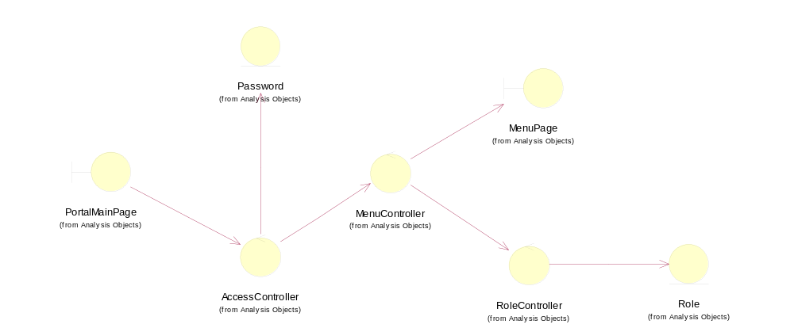

Derived Requirements
Portal Administrator, User Administrator and User all can access the Portal Main Page, and login their respective MenuPage according to their pre-defined role.

